Window IOT Beginner Kit

Hardware List:

* Raspberry Pi Module B
* Arduino Expansion Shield for Raspberry Pi B+
* Magnet Micro USB Cable
* CAT 5 Ethernet Cable
* HDMI Cable
* Micro SD Memory Card 16GB Class10
* USB Keyboard
* USB Mouse

Hardware Connection:

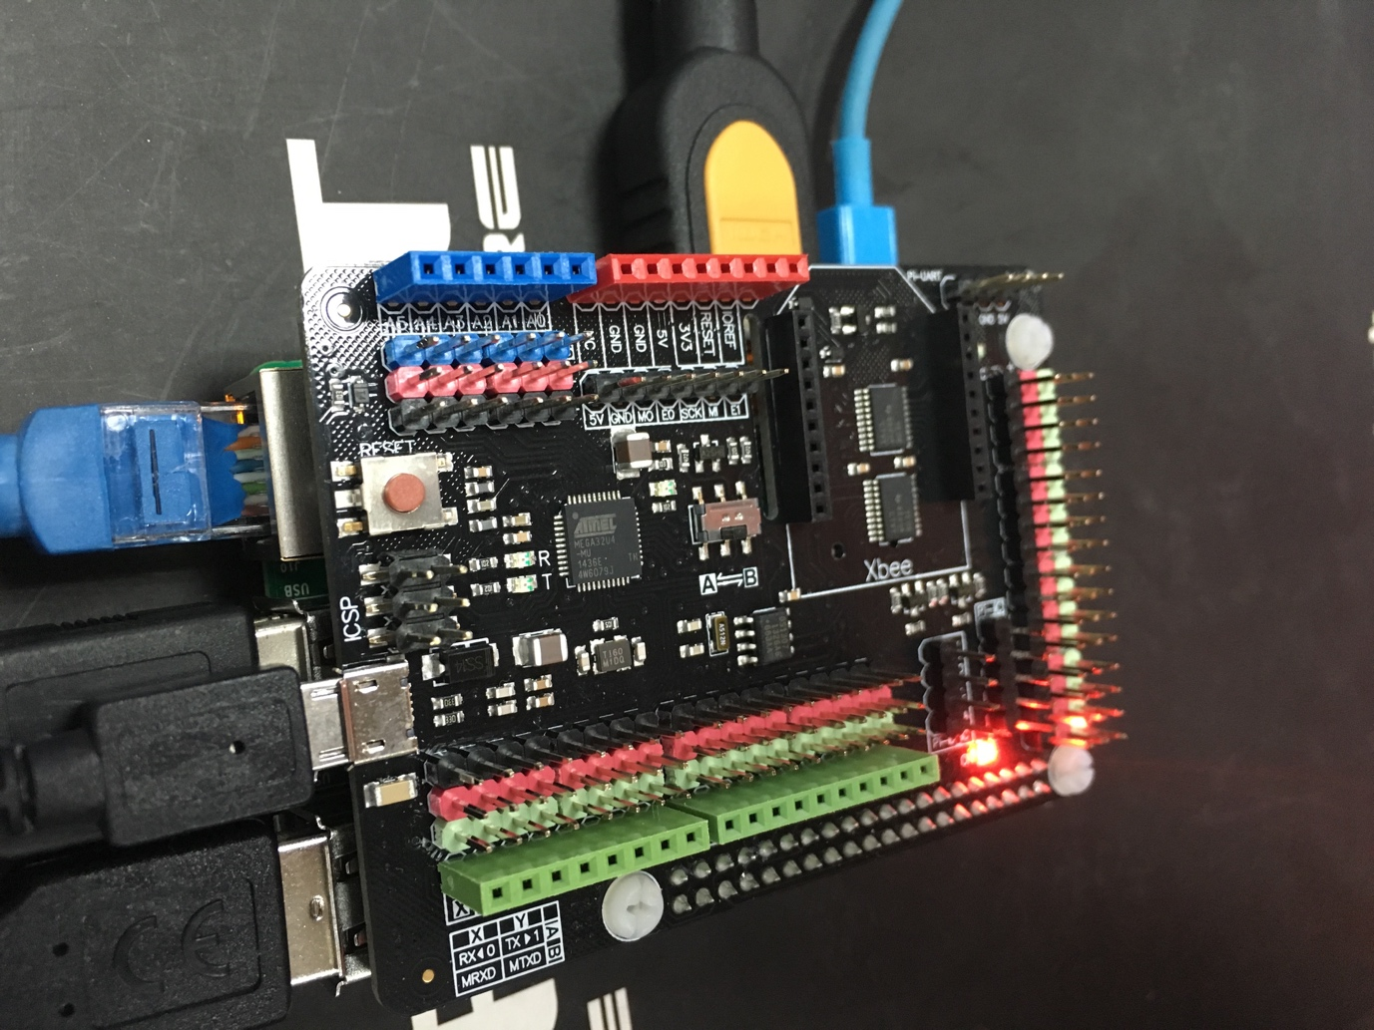

1. Make sure you are running Windows 10 (version 10.0.10240) or better. Typing “winver” to check the Version.

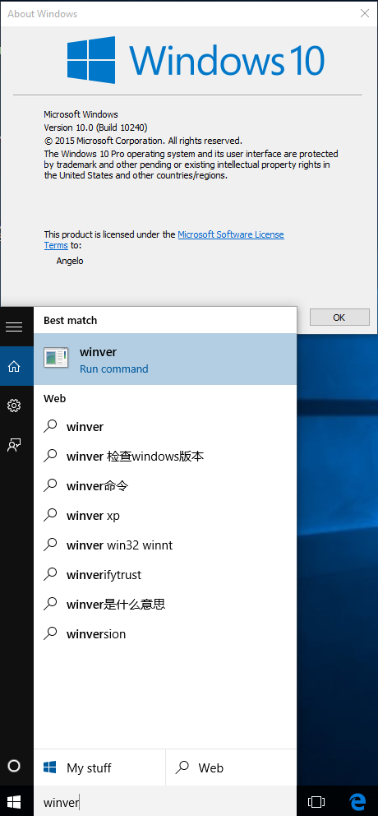

1. Download Visual Studio 2015 Here:

<https://www.visualstudio.com/downloads/download-visual-studio-vs>



1. Install It, remember to select the “Universal Windows App Development Tools”:

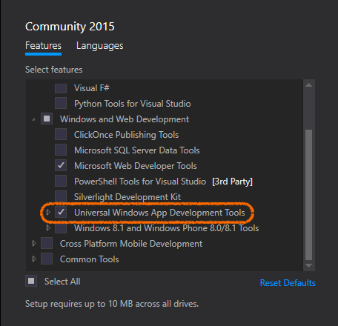

1. Install Windows IoT Core Project Templates

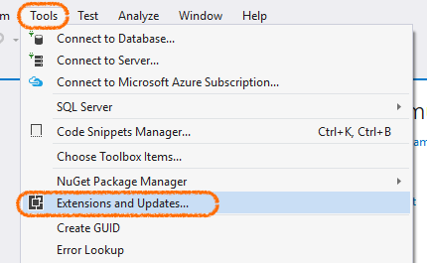

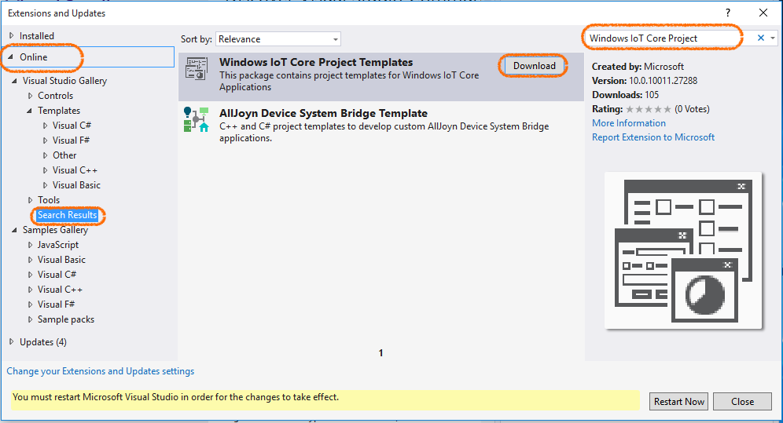

1. Enable developer mode

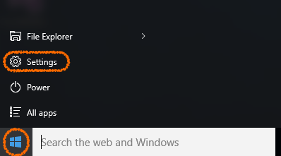 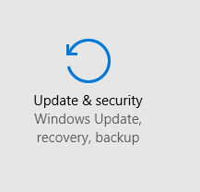

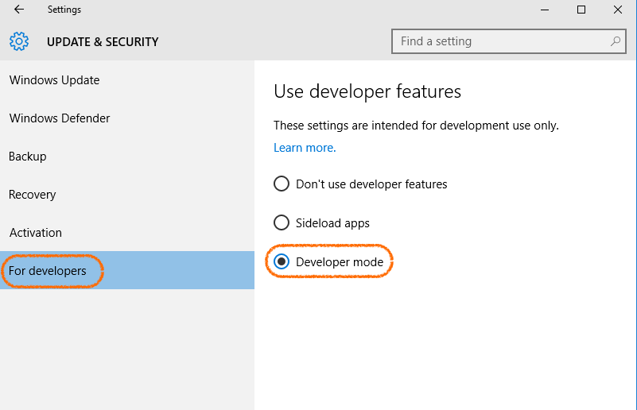

Set up the Raspberry Pi

1. Download a Windows 10 IoT Core image here:

<http://ms-iot.github.io/content/en-US/Downloads.htm>

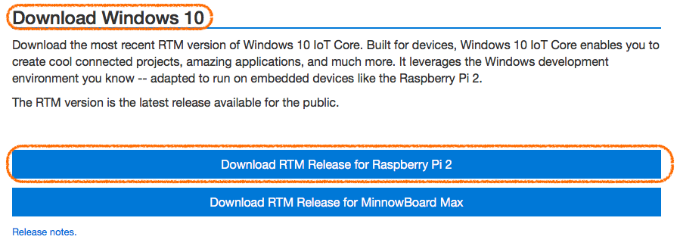

1. Install Windows_10_IoT_Core_RPi2.msi

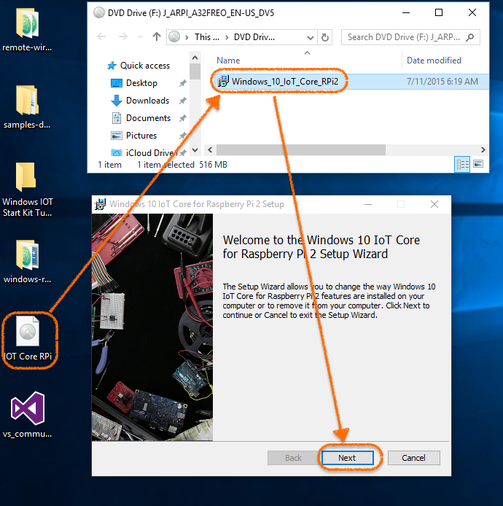

1. Browse into “C:\Program Files (x86)\Microsoft IoT”

Open “IoTCoreImageHelper.exe”

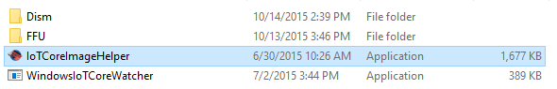

1. Insert the micro SD card and select the image file: “C:\Program Files (x86)\Microsoft IoT\FFU\RaspberryPi2\flash.ffu”

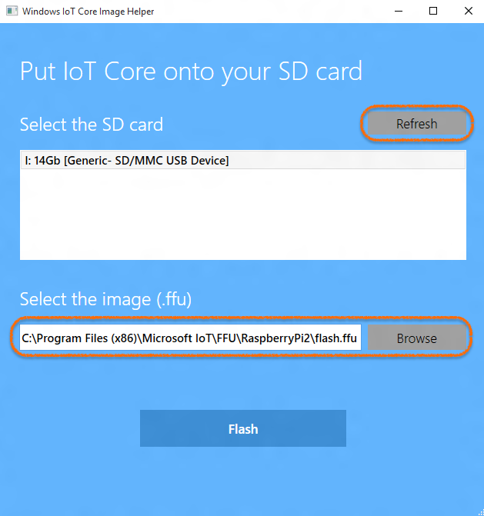

1. Safely remove your USB SD card reader.

Failing to do this can cause corruption of the image.

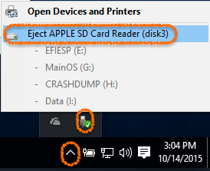

1. Insert your Micro SD card to Raspberry Pi. And connect power supply.

The windows 10 IOT is successfully booted. Some basic device information is here and you can use your mouse to control it.

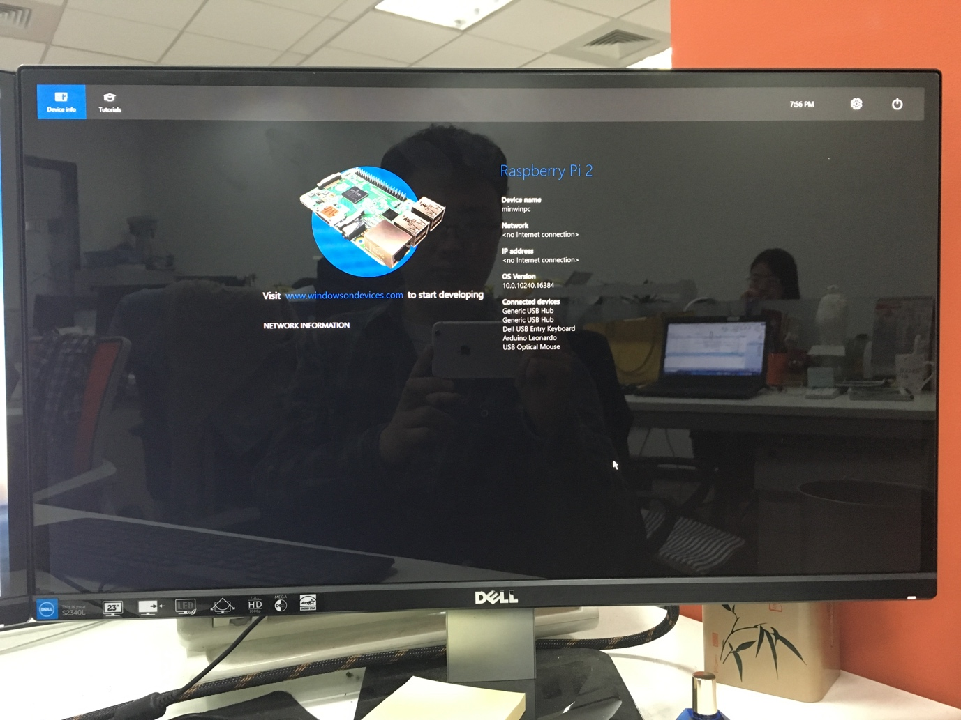

Set up the Arduino:

1. Connect the Raspberry Pi Shield to the PC.
2. Open Arduino. And select the “StandardFirmata”

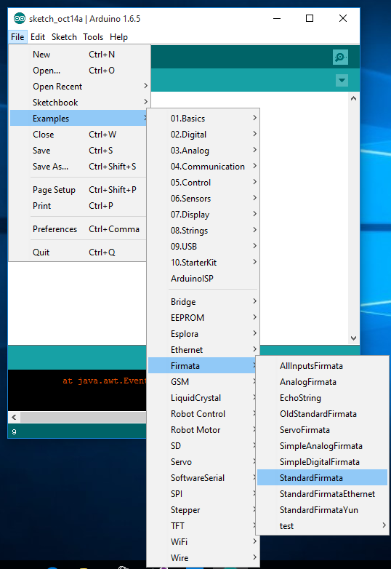

1. Select “Arduino Leonardo”

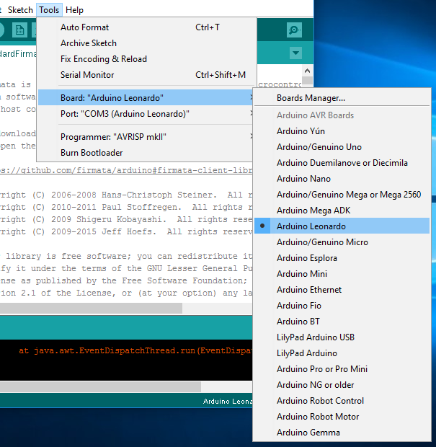

1. Select the proper COM port:

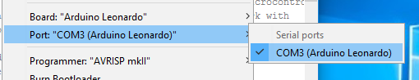

1. Upload the sketch

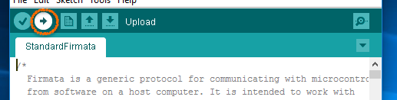

1. Upload Down



Blink your board:

1. Open Visual Studio 2015 and create a new APP:



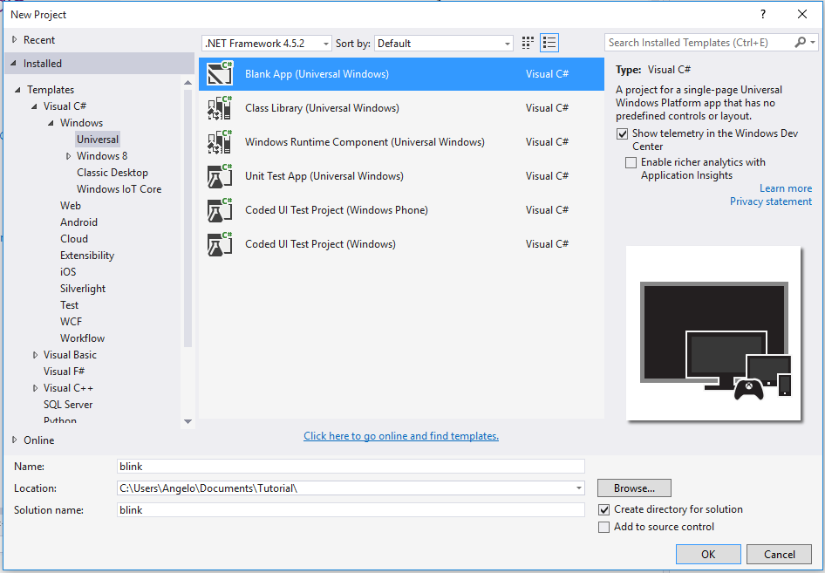

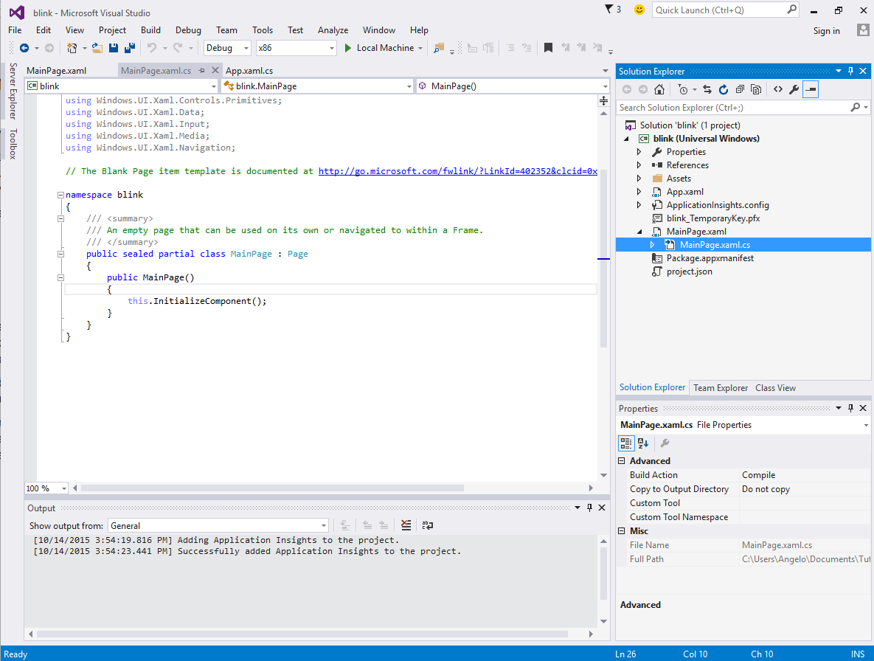

1. Download the dependent library:

<https://github.com/ms-iot/remote-wiring>

1. Decompress the zip file:

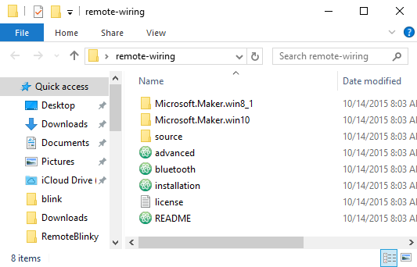

1. Add the reference library:

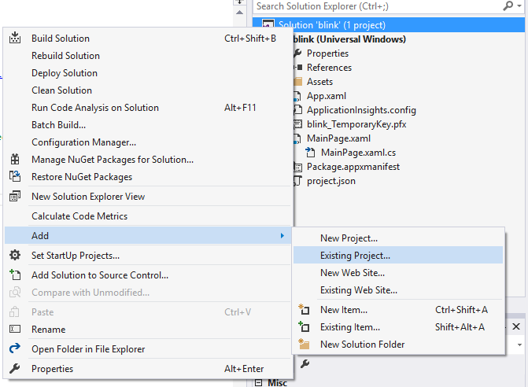

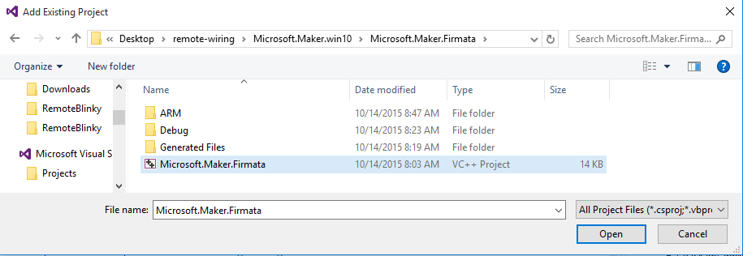

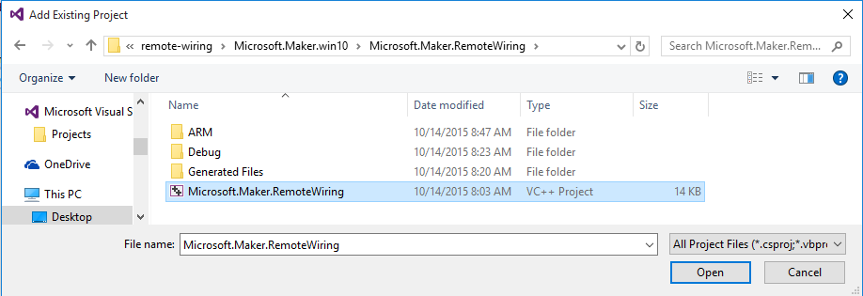





1. Add reference:

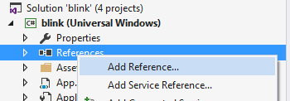

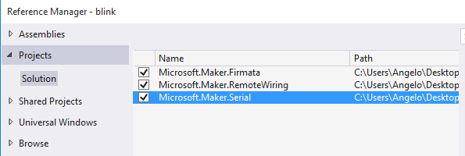

1. Enabling USB Capabilities



1. Add following code here:

<DeviceCapability Name="serialcommunication">

<Device Id="any">

<Function Type="name:serialPort"/>

</Device>

</DeviceCapability>

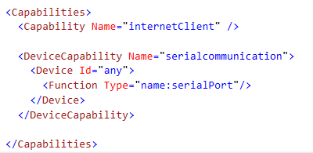

1. Change the Target to ARM:

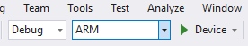

1. Change the target device to Remote Machine:



1. Select your raspberry Pi on the network

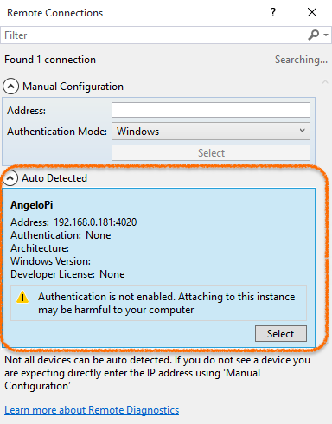

1. Rebuild Solution

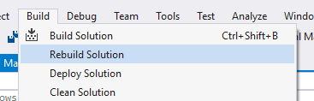

1. 在 MainPage 内键入代码:



using System;

using System.Collections.Generic;

using System.IO;

using System.Linq;

using System.Runtime.InteropServices.WindowsRuntime;

using Windows.Foundation;

using Windows.Foundation.Collections;

using Windows.UI.Xaml;

using Windows.UI.Xaml.Controls;

using Windows.UI.Xaml.Controls.Primitives;

using Windows.UI.Xaml.Data;

using Windows.UI.Xaml.Input;

using Windows.UI.Xaml.Media;

using Windows.UI.Xaml.Navigation;

using Microsoft.Maker.Firmata;

using Microsoft.Maker.RemoteWiring;

using Microsoft.Maker.Serial;

// The Blank Page item template is documented at http://go.microsoft.com/fwlink/?LinkId=402352&clcid=0x409

namespace blink

{

/// <summary>

/// An empty page that can be used on its own or navigated to within a Frame.

/// </summary>

public sealed partial class MainPage : Page

{

UsbSerial usb;

RemoteDevice arduino;

private DispatcherTimer timer;

private const int LED_PIN = 13;

private PinState pinValue;

public MainPage()

{

this.InitializeComponent();

usb = new UsbSerial("VID_2341", "PID_8036"); //I've written in my device D directly

arduino = new RemoteDevice(usb);

usb.ConnectionEstablished += OnConnectionEstablished;

//SerialConfig.8N1 is the default config for Arduino devices over USB

usb.begin(115200, SerialConfig.SERIAL_8N1);

}

private void Timer_Tick(object sender, object e)

{

if (pinValue == PinState.HIGH)

{

arduino.digitalWrite(LED_PIN, PinState.LOW);

pinValue = PinState.LOW;

}

else

{

arduino.digitalWrite(LED_PIN, PinState.HIGH);

pinValue = PinState.HIGH;

}

}

private void OnConnectionEstablished()

{

timer = new DispatcherTimer();

timer.Interval = TimeSpan.FromMilliseconds(1000);

timer.Tick += Timer_Tick;

arduino.pinMode(LED_PIN, PinMode.OUTPUT);

timer.Start();

}

}

}

1. Blink 成功:

